**Linux Programming**

**LAB EXERCISE**

Nirmal.M

17MIS1075

**Q1**

**Code:**

sudo apt-get install sl

sl

**ScreenShot:**

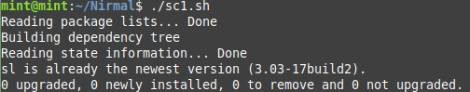

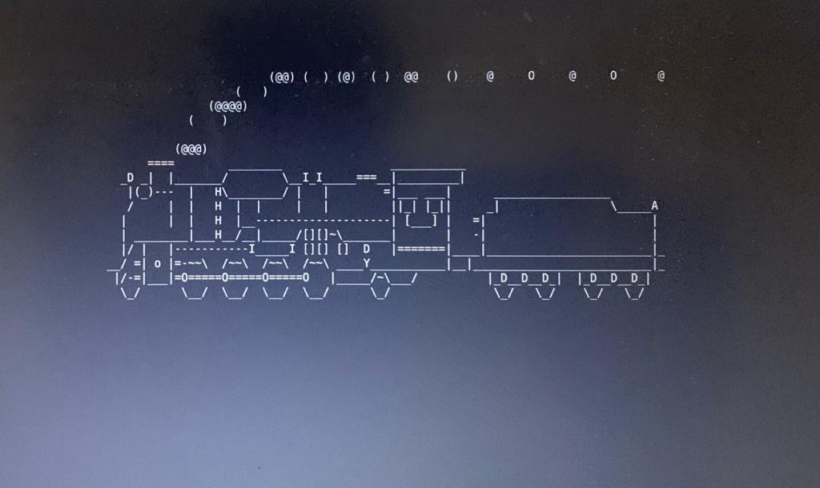

**Q2:**

**Code:**

Rev

**ScreenShot:**

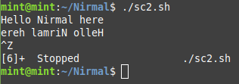

**Q3:**

**Code:**

vmstat 1200 > vmstat1.data

filename= "/Nirmal/vmstat1.data"

tail -f $filename |

while read $line do

if [ (cat vmstat1.data | grep "swpd")>0 ]

then

echo "Some Rogue Process has consumed massive amounts of Memory"> swap.txt

fi

if [ (cat vmstat1.data | grep "r")>1 ]

then

echo "Some processes are waiting to execute"> runqueue.txt

fi

if [ (cat vmstat1.data | grep "cpu")>1000 ]

then

echo "CPU usage is more"> cpu.txt

fi

End

**ScreenShot:**

